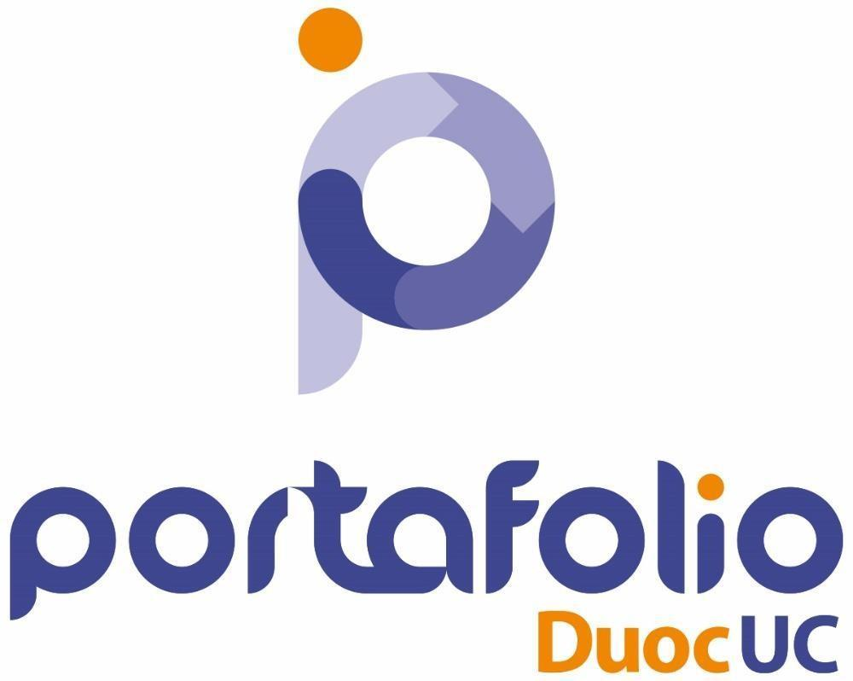



Abstract, Reflexión y Conclusiones proyecto EnergyMeter 2024



**Proyecto APT- Fase 1 Proceso Portafolio de Título**

| Nombre Completo | *Francisco David Galdames Sanhueza* |
| --- | --- |
| Rut | *21234420-6* |
| Carrera | *Ingeniería en informática* |
| Sede | *DuocUC Plaza Maipú* |

| Nombre Completo | *Jorge Antonio Parra Araneda* |
| --- | --- |
| Rut | *21196239-9* |
| Carrera | *Ingeniería en informática* |
| Sede | *DuocUC Plaza Maipú* |

| Nombre Completo | *Gabriel Ignacio Soto Ibañez* |
| --- | --- |
| Rut | *20532134-9* |
| Carrera | *Ingeniería en informática* |
| Sede | *DuocUC Plaza Maipú* |

# 

# Índice

**Índice** **2**

**Abstracto** **2**

**Abstract** **2**

**Individual Conclusions** **2**

Conclusion of Francisco Galdames 2

Conclusion of Jorge Parra 3

Conclusion of Gabriel Soto 3

**Reflection** **3**

**Reflexión** **3**

# 

# Abstracto

La filosofía de nuestro proyecto APT consiste en lograr satisfacer algunas de las necesidades que ciertas empresas de electricidad chilenas no han sabido cubrir de forma efectiva. Hoy en día algo tan importante que incluso se ve en lo cotidiano es el streaming, se usa tanto para el entretenimiento o para el trabajo. En esta ocasión lo utilizaremos como una herramienta para poder visualizar el consumo eléctrico de los artefactos de nuestro hogar en tiempo real.

**¿Cómo lograremos este cometido si el solo hecho de alterar el medidor de electricidad puede considerarse como una violacion al contrato?** Muy simple, no lo haremos. Planeamos utilizar dispositivos como ESP32, Arduinos o incluso Raspberry Pi para construir dispositivos que funcionen de la misma manera que funcione un medidor de watts, con la diferencia que estos tendrán la capacidad de conectarse a la red wifi del hogar. Con esto logramos el mismo cometido que hace el medidor del hogar e incluso más, sin alterar la infraestructura de la empresa.

Nuestro proyecto es un software como servicio, en el cual el modelo de negocio a seguir sería la venta de los dispositivos IoT para medir la electricidad, mientras que los servicios de dashboard web y móvil será ofrecido de forma gratuita.

# Abstract

The philosophy of our APT project is to meet some of the needs that certain Chilean electricity companies have not effectively reached. Nowadays, something as common and important as streaming is used for entertainment and work. On this occasion, we will use it as a tool to visualize the real-time electricity consumption of household appliances.

**How will we achieve this goal without altering the electricity meter, which could be considered a violation of the contract?** Simple, we won't. We plan to use devices like ESP32, Arduinos, or even Raspberry Pi to build devices that function similarly to a watt meter, with the added capability of connecting to the home's wifi network. This way, we achieve the same goal as the household meter, and even more, without altering the company's infrastructure.

Our project is a software as a service, where the business approach involves selling IoT devices to measure electricity, while the web and mobile dashboard services will be offered for free.

# Desarrollo de ingeniería

Como mencionamos con anterioridad, planeamos construir un dispositivo medidor de Watts con un Esp32 o equivalente. Este dispositivo funcionará de intermediario entre el enchufe de corriente alterna de la residencia y el dispositivo a conectar, logrando que el esp pueda obtener todas las mediciones necesarias como el amperaje, el voltaje y tener un precálculo del Watt consumido para ser posteriormente enviado a un servidor externo en el cual este probablemente hosteado en una instancia VPS (Virtual Private Server) cloud usando el puerto MQTT (Message Queuing Telemetry Transport) para luego ser procesado por una API en tiempo real, y que esta api sea consumida por un front end escrito en el framework NextJS, este frontend no estaría en el mismo servidor de la API,sino que planeamos utilizar Vercel por las facilidades que nos da al momento de elegir un dominio de bajo costo y más personalizable. Algunos valores como el precio por KwH será un valor parametrizado debido a que no todas las casas tienen el mismo tipo de contrato de servicio de electricidad. Por lo que preferimos que cada usuario tenga ese valor personalizado.

Adicionalmente, el frontend contará con soporte para PWA (Progressive Web Apps) para poder tener una multiplataforma (Mac, Windows, Android, IOS y Linux) sin la necesidad de tener que recodificar algo, solo preocupándonos por que la aplicación sea responsiva, sin embargo se requerirá de que el usuario use un navegador basado en Chromium para que esto sea efectuado de manera correcta (Google Chrome, Microsoft Edge, Brave, Ópera y sus variaciones, etc.)

# Individual Conclusions

## Conclusion of Francisco Galdames

I believe that this project will help people economically. Apart from this, people will be able to educate themselves and learn ways to save energy more easily by having feedback on the service that our project offers. Thanks to our service, many people will be able to avoid bills with amounts that are too large and know that they are consuming a lot of electricity in their home, in order to apply measures. Personally, I think that the money for the development is the main issue for this project. Investors are a key factor in the success of this project. Without sufficient funding, it would be challenging to bring the service to market, invest in the necessary technology, and scale it effectively.

## Conclusion of Jorge Parra

Personally, I consider this project can help a lot of people to become aware of how we waste of energy and get a better management of the day in a good way, thanks to our suggestion for domestic use, which encourages a comfortable way to watch the electricity Spending by connecting with a web interface without concern with the electric service.

The implications here are about how we are going to do the project. The complexity of the programming, manufacturing and testing of the hardware prototype implies more use of time and the implication of using our money to make the physical prototype possible, but still, I see this project potential in the market with enough time and recourse to develop the idea.

## Conclusion of Gabriel Soto

Personally, I believe that our project is very capable of entering the market and selling well if there is investment involved to manufacture the devices. It would be necessary for the devices to be accessible to the public so that people would buy several.

The problem lies in the fact that manufacturing each device individually would be an issue for us; we heavily depend on economies of scale to be able to manufacture the devices and for our project to stand out, which is our biggest challenge.

However, I believe that generating both physical and digital prototypes can initially address this problem. Once investors are secured to develop the means to manufacture the devices, such as molds, PCB design for optimizing product space, firmware programming, etc., we could significantly improve the quality of the product once we have investors interested in this project.

# Reflection

**This project does not aim to perform magic with our clients electricity usage**, our goal is to make them aware of their consumption by getting real-time information, displaying electricity data obtained from our devices in a graphical, user friendly, and interactive way. This contrasts with what an electricity company might offer, which usually provides a monthly consumption summary with limited detail in some cases.

We believe this gives us a significant advantage, as it allows us to generate instant statistics using the constant data flow (also known as streaming) and start answering some questions such as:

* Which appliance consumes the most electricity in my home?
* Is there an electrical leak in my premises?
* Which of these two devices offers better kWh efficiency?

Additionally, by keeping everything in a modular way, we ensure that our service will work as universal as possible, allowing us to operate with any type of house, even if it has an electricity contract, or uses renewable energy sources, or even operates exclusively with electric generators.